GROUP 3
Roman kOROLOVYCH GVIDONAS BUIKYS
Gaming EcoSYSTEM

Stage 3 – Lab Report

Gaming Ecosystem – Gvidonas & Roman

Section 1: Final ER Diagram
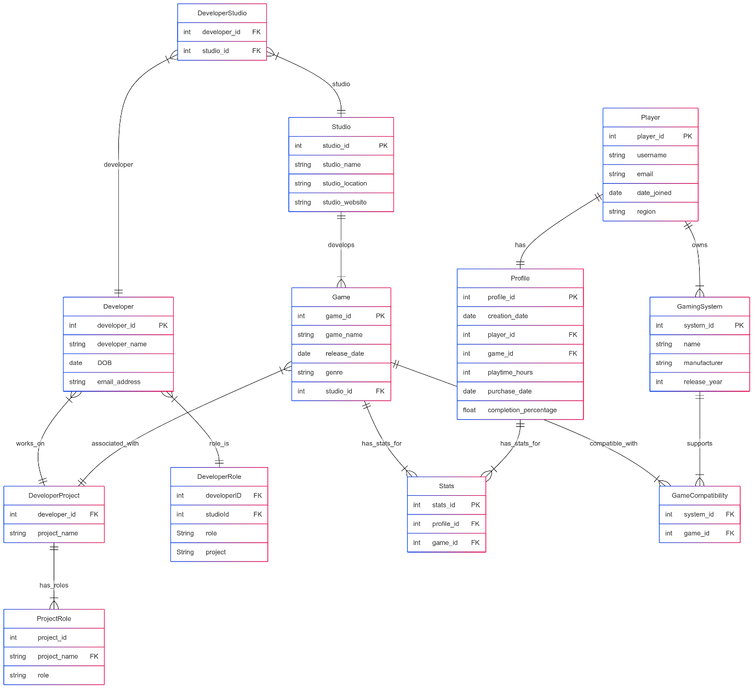

Section 2: 10 Queries

Query 1: Get players with less than 50 hours of playtime

SQL statement
SELECT
player.ID,
player.Username,
profile.playtime_hours
FROM
player
JOIN
profile ON player.ID = profile.player_id
WHERE
profile.playtime_hours < 50;

Explanation
This SQL Query retrieves a list of players who have played for less than 50 hours. It does this by:
- Selecting the player’s ID and Username from the player table.
- Joining the player table with the profile table using a JOIN on the matching ID from player and player ID from profile.
- Filtering the results with a WHERE clause so that only records where playtime hours is less than 50 are returned.
The result shows which users are less active based on their total hours played.

Query 2: Retrieves the total number of consoles for each manufacturer

SQL statement
SELECT manufacturer, COUNT(name) AS total_consoles
FROM gaming_system
GROUP BY manufacturer
ORDER BY total_consoles DESC;

Explanation:
This SQL query shows how many gaming consoles each manufacturer has produced, sorted from the highest to the lowest.
- It selects the manufacturer name from the gaming system table.
- It counts the number of entries in the name column(i.e, different console models) for each manufacturer using COUNT(Name).
- The GROUP by manufacturer groups the results so that the count is calculated per manufacturer.
- The ORDER by total consoles DESC sorts the output in descending order, so the manufacturer with the most console models appears first.
This is useful for identifying which manufacturers are most active or diverse in their gaming system production.

Query 3: Retrieve the latest game for each genre

SQL statement
SELECT game_name, release_date, genre
FROM game g
WHERE release_date = (
SELECT MAX(release_date)
FROM game
WHERE genre = g.genre
)
ORDER BY genre;

Explanation:
This query retrieves the most recently released game in each genre from the game table
- It selects the game name, release date, and genre from the game table (aliased as g)
- The WHERE clause uses a subquery to find the maximum (latest) release date for each genre.
- The subquery compares each row’s release date with the maximum date for that specific genre (WHERE genre = g.genre), ensuring only the latest game per genre is returned.
- The results are then ordered by genre for easier readability and grouping.
This is helpful when you want to highlight the newest game in every genre category.

Query 4: Retrieves the top 5 players with the highest average game completion percentage

SQL statement
SELECT
player.ID,
player.Username,
ROUND(AVG(profile.completion_percentage), 2) AS avg_completion
FROM player
JOIN profile ON player.ID = profile.player_id
GROUP BY player.ID, player.Username
ORDER BY avg_completion DESC
LIMIT 5;

Explanation:
This query displays the top 5 players with the highest average game completion percentage.
- It selects the ID and Username from the player table.
- It JOINS the player table with the profile table using the player’s ID
- It calculates the average completion percentage for each player using AVG(profile completion percentage) and rounds it to 2 decimal places with ROUND(…,2)
- This data is grouped by player ID and username to ensure the average is calculated per player
- It orders the results in descending order based on average completion so that the top players appears first.
- The LIMIT 5 ensures that only top 5 players are shown.
This query is useful for leaderboard-style statistics based on how thoroughly players complete their games.

Query 5: Rank Sony consoles released between 2015 and 2023 by latest release

SQL statement
SELECT
name,
manufacturer,
release_year,
RANK() OVER (ORDER BY release_year DESC) AS release_rank
FROM gaming_system
WHERE manufacturer = 'Sony'
AND release_year BETWEEN 2015 AND 2023;

Explanation:
This query lists Sony gaming systems released between 2015 and 2023, ranked by their release year from newest to oldest.
- It selects the name, manufacturer, and release year from the gaming system table.
- The WHERE clause filters the results to only include systems made by ‘Sony’ and released between 2015 and 2023.
- It uses the RANK() window function with OVER(ORDER By release DESC) to assign rank to each console based on how recently it was released – newer consoles get a higher rank (i.e, lower number).
- The result includes a release rank column showing this order
This helpful for seeing Sony’s console release timeline and comparing the relative order of their newer systems.

Query 6: Show players whose playtime is greater than the average playtime

SQL statement
SELECT player.Username, SUM(profile.playtime_hours) AS total_playtime
FROM player
JOIN profile ON player.ID = profile.player_id
GROUP BY player.Username
HAVING total_playtime > (
SELECT AVG(playtime_hours) FROM profile
);

Explanation:
This query shows the usernames of players whose total playtime is above the average playtime across all profiles.
- It joins the player and profile tables on the player’s ID
- It groups the results by player username and calculates the total playtime for each player using SUM(profile playtime hours)
- The HAVING clause filters out players whose total playtime is less than or equal to the average The average is computed with a subquery: SELECT AVG(playtime hours) FROM profile
- Only those players whose total playtime is greater than the overall average are included in the final result.
This is useful for identifying the most active or engaged players based on total hours played.

Query 7: Classify players based on their total playtime hours

SQL statement
SELECT
Player.Username,
SUM(Profile.playtime_hours) AS total_playtime,
CASE
WHEN SUM(Profile.playtime_hours) > 100 THEN 'Hardcore'
WHEN SUM(Profile.playtime_hours) > 50 THEN 'Regular'
WHEN SUM(Profile.playtime_hours) > 10 THEN 'Casual'
ELSE 'Newbie'
END AS player_category
FROM Player
JOIN Profile ON Player.ID = Profile.player_id
GROUP BY Player.Username
ORDER BY total_playtime DESC;

Explanation:
This query classifies players based on their total playtime into categories like Hardcore, Regular, Casual or Newbie.
- It joins player and profile tables using the player ID
- It calculates the total playtime for each player by summing profile playtime hours using SUM
- It uses CASE statement to assign a player category:
- Hardcore for playtime over 100 hours
- Regular for over 50 hours
- Casual for over 10 hours
- Newbie for 10 or fewer hours
- The results are grouped by player username so each player appears once.
- Finally, the list is sorted by total playtime in descending order so the most active players are listed first.
This is great for generating a simple engagement-based player segmentation.

Query 8: Find all developers that have Director in their role

SQL statement
SELECT DISTINCT
Developer.developer_name,
Project_Role.Role
FROM
Developer
JOIN
Developer_Project ON Developer.developer_id = Developer_Project.Developer_ID
JOIN
Project_Role ON Developer_Project.Project = Project_Role.Project
WHERE
Project_Role.Role LIKE '%Director%'
ORDER BY
Developer.developer_name;

Explanation:
This query lists all distinct developers who held a role containing the word “Director” on any project.
- It performs a series of joins between the Developer, developer project, and project role tables to link developers to their roles in projects
- The WHERE clause filters for roles that include the term “Director” using LIKE ‘%Director%’(e.g. Game Director, Art Director).
- SELECT DISTINCT ensures that each developer-role combination appears only once on the results.
- The output includes the developer name and their matching role.
- The final result is sorted alphabetically by developer name
This query is useful for identifying key leadership contributors across development projects.

Query 9: Get the best performing developers based on their game rating which is calculated based on average completion and playtime

SQL statement
WITH GameRatings AS (
SELECT
Game.game_id,
game_name,
ROUND(AVG(completion_percentage),2) AS avg_completion,
ROUND(AVG(playtime_hours),2) AS avg_playtime,
ROUND(AVG((playtime_hours+completion_percentage)/2),2) AS game_rating
FROM
Profile
JOIN
Game ON Profile.game_id = Game.game_id
GROUP BY
Game.game_id, game_name
)

SELECT
Developer.developer_name,
Studio.studio_name,
GameRatings.game_name,
GameRatings.avg_completion,
GameRatings.avg_playtime,
GameRatings.game_rating
FROM
Developer
JOIN
Developer_Studio ON Developer.developer_id = Developer_Studio.Developer_ID
JOIN
Studio ON Developer_Studio.studio_id = Studio.studio_id
JOIN
Game ON Studio.studio_id = Game.studio_id
JOIN
GameRatings ON Game.game_id = GameRatings.game_id
ORDER BY
GameRatings.game_rating DESC

Explanation:
This SQL query provides a ranked list of games developed by specific studios, including their average completion, playtime, and a calculated game rating, along with the developers and studios behind them.
A common table expression (CTE) named Game ratings is created to:
- Calculate the average completion percentage, average playtime, and custom game rating(average of completion and playtime) for each game.
- The data comes from joining profile and game tables
- Results are grouped by each genre (game ID, game name) and rounded to 2 decimal places for readability.
Final Select
This part retrieves:
- The developer name, studio name, all fields from Game ratings.
- It joins multiple tables (Developer, Developer studio, studio, game, and game ratings) to associate developers with studios and their games.
- Finally, it orders the results by game rating in descending order so the top-rated games appear first.
This query is powerful for performance analysis, allowing you to see which developers and studios are producing the most engaging games based on aggregated player date.

Query 10: Purpose: Create a basic view of studio game statistics,

SQL statement
CREATE VIEW Studio_Game_Stats AS
SELECT
Studio.studio_id,
Studio.studio_name,
COUNT(Game.game_id) AS number_of_games,
MIN(Game.release_date) AS first_release,
MAX(Game.release_date) AS latest_release
FROM
Studio
LEFT JOIN
Game ON Studio.studio_id = Game.studio_id
GROUP BY
Studio.studio_id, Studio.studio_name;

SELECT
studio_name,
number_of_games,
first_release,
latest_release,

YEAR(CURRENT_DATE()) - YEAR(first_release) AS years_active
FROM
Studio_Game_Stats
WHERE
number_of_games >= 2
AND latest_release >= '2022-01-01'
ORDER BY
number_of_games DESC;

Explanation:
Part 1 – Create VIEW studio game stats:
This view summarizes basic game release statistics per studio
- It joins the studio and Game tables (using a LEFT JOIN to include studios that may have no games)
- For each studio, it calculates:
- The total number of games (COUNT(Game.Game ID))
- The first release date (MIN(…))
- The last release date (MAX(…))
- The results are grouped by the studios ID and name
Part 2 – Final SELECT from Studios Game stats
This query filters and present key data for studios with at least 2 games and a recent release (2022 or later).
- It selects each studios name, number of games, first and latest release dates.
- It also calculates how long the studio has been active by subtracting the year of their first release from the current year:
YEAR (CURRENT DATE()- YEAR(FIRST RELEASE)AS years active)
- The results are sorted by the number of games, showing the most prolific studios first.
This is great for spotting active and long-standing studios with recent output.

Screenshots of each Query working in JAVA

Query 1
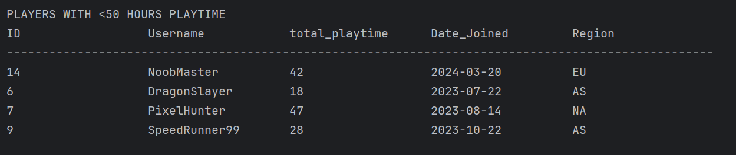
Query 2
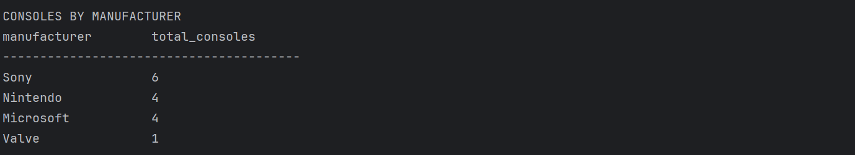
Query 3
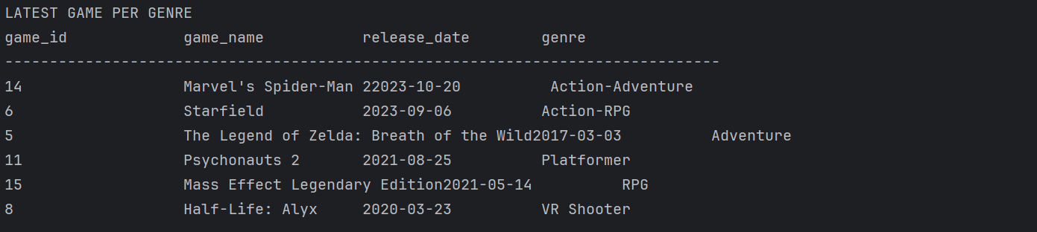
Query 4
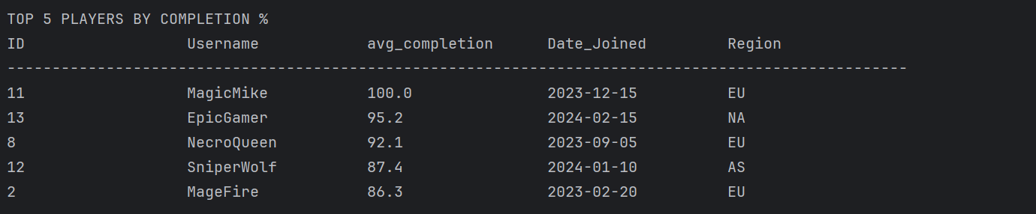
Query 5
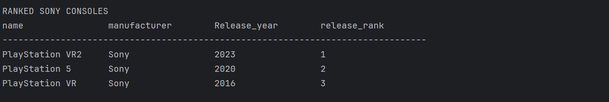
Query 6
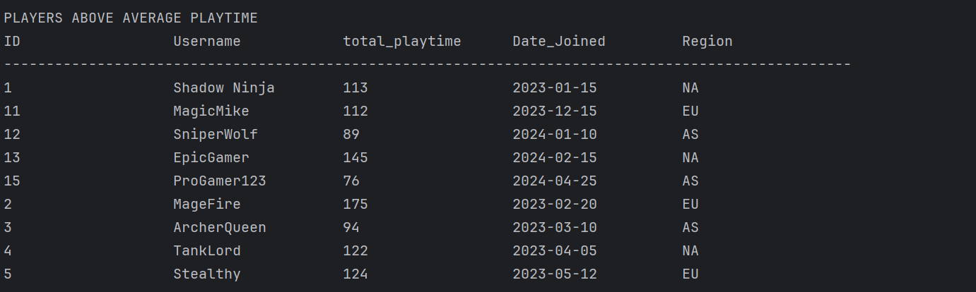
Query 7
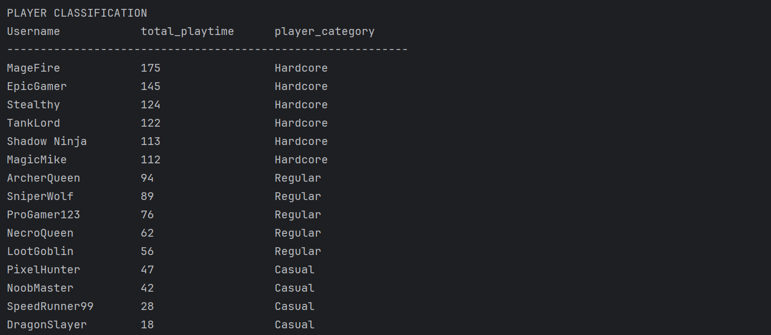
Query 8
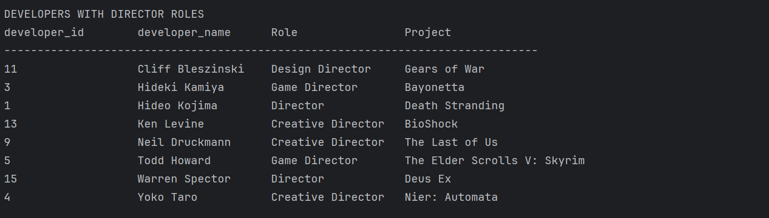
Query 9
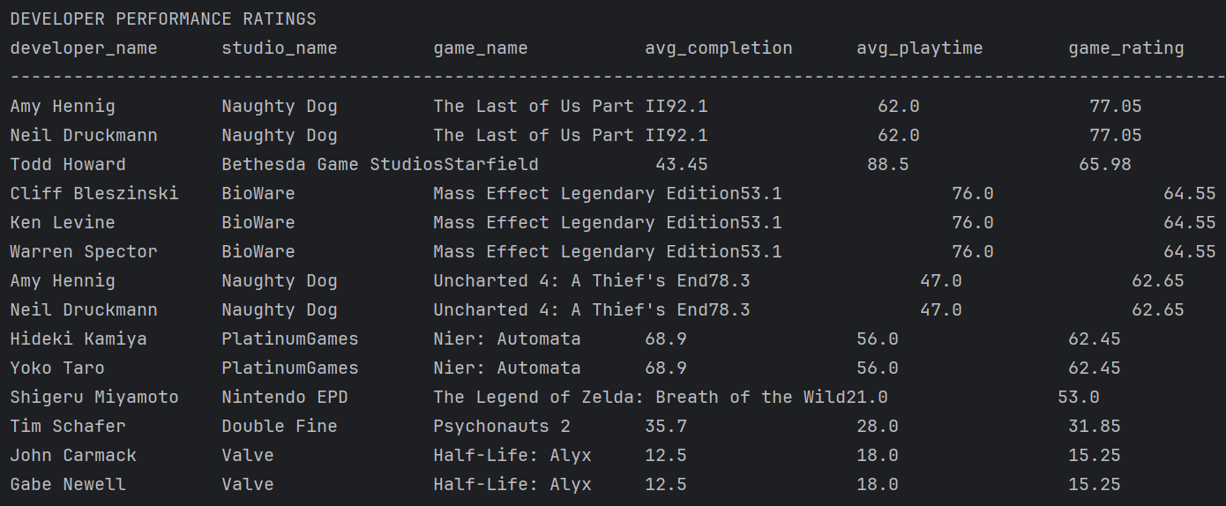

Query 10
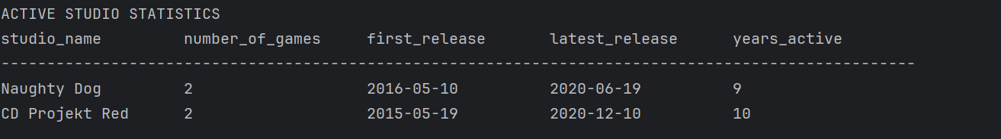

Section 3: Responsibilities
Task / Component | Gvidonas Buikys (D00280972) | Roman Korolovych (D0080847)
SQL Schema | ✅
Queries 1–5 | ✅
Queries 6–10 |  | ✅
Java – DBConnect |  | ✅
Java – DBCommand |  | ✅
Java – OutputFormatter |  | ✅
Java – Main |  | ✅
ER Diagram (Mermaid) | ✅
PDF Section 1 & 2 | ✅
PDF Compilation & Formatting | ✅
Testing – SQLite | ✅
Testing – Java Code |  | ✅

